

**종합설계 프로젝트**

**PreFuture**

**Dynamic Presentation**

**Requirements Specification**

**담당교수 : 이석원 교수님**

**담당조교 : 고태형 조교**

**제 출 일 :**

**조 원 :200620334 오희준**

**200620316 신대욱**

**200722160 박태선**

**200822166 박철룡**



[1. Projects Overview 3](#_Toc323330250)

[1.1. Scope and Objectives 3](#_Toc323330251)

[**1.2. Supplementary Requirements** 4](#_Toc323330252)

[2. Customer Requirements 6](#_Toc323330253)

[2.1 User requirements 7](#_Toc323330254)

[2.2 System requirements 8](#_Toc323330255)

[2.3 Domain requirements 9](#_Toc323330256)

[**3. Requirements Analysis** 9](#_Toc323330257)

[3.1Structural Analysis 9](#_Toc323330258)

[3.2. Behavioral Analysis 12](#_Toc323330259)

[**3.3Analysis Packages** 23](#_Toc323330260)

[**4. Validation Criteria (metrics & measures)** 24](#_Toc323330261)

[**5. Appendices** 25](#_Toc323330262)

# 1. Projects Overview

<Dynamic Presentation> aimed to provide easily an All-in-one technology to user for presentation when environment for presentation is not prepared in advance or a lack of equipment. A number of mike and remote-control application, based on Android platform, already developed. Because of some problems, for example delay, noise or UI without user experience, inconveniences often arise. Dynamic presentation can improves problems that existing system have and provides various and useful functions for user.

## 1.1. Scope and Objectives

**1.1.1. Change about presentation tool - All-in-one**

Dynamic Presentation provides just one system integrating mike, keyboard, pointing using Gyroscope sensor and virtual storage. This can replace existing mouse for presentation, control keyboard and mouse action and use documents with file management easily. The service containing mobility and convenience can be developed for presentation.

**1.1.2. Improvement about presentation environment - Anywhere**

Dynamic Presentation operates in Wireless network environment like 3G and Wi-Fi. Everywhere wireless network worked user can this anywhere.

**1.1.3. Scope**

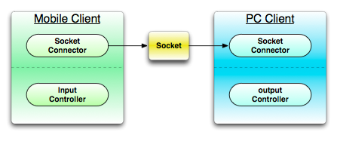

**1.1.3.1. Mobile Client**  
- Mobile Graphic User Interface

-Communication for connecting PC

- Mike, Recording

- Cloud service

- Keyboard action control

- Mouse action control

**1.1.3.2. PC Client**  
- Communication for connecting mobile device

- Output voice streaming

- Cloud service

- Keyboard action control

- Mouse action control

**1.2. Supplementary Requirements**

**Introduction**

This document includes all requirements that aren’t extracted when making Use case.

**Functionality**• Logging and Error Handling  
- Every errors have to be saved in storage.  
• Pluggable Rule  
- System’s functions can be specialized using optional regulation that will be invoked at the point generating various scenario of Use Case.  
• Security  
- All user must be authorized.  
  
**Usability**  
• document  
- A manual that defined way to use is needed.  
- A help mode that explained each functions is needed.  
- A problem-solving document containing problems and solution is needed.  
  
• **Human Factors**  
- Customer can see Dynamic Presentation system using proper sized screen. So, the letters have to consist of suitable color, size and font.  
- Customer wants to use Dynamic Presentation quickly. Then he/she has not a correct understanding. Thus, it is a critical factor to prevent error generating and use system easily.  
  
**Reliability**  
• Recoverability  
- If system has problem with external problem, alternative is prepared in advance in order to handle that immediately.  
• Responsibility  
- The system sensor events (touch, acceleration and gravity) will respond to more than 95%.Because the value is to passed exactly.  
- A value of sensor that user inputs have to respond within 0.1 seconds.  
  
**Performance**  
• Speed  
- As be said in the Human Factors section, customer want to use Dynamic Presentation quickly. Therefore, delay has to take 0.5 second at most when system is used.  
  
**Supportability**  
• Internationality  
- System provides an English service for foreigner who has no ability in a Korean.  
  
**Implementation Constraints**  
• System have to be implemented using Java technical solution. It is anticipated to give a guarantee of portability and scalability.  
• System have to be implemented using Android SDK 2.3.

**Interfaces**  
• Hardware Interfaces  
- Smartphone(Android SDK 2.3.3, Android API Ver.10)  
- Laptop or Desktop  
  
• Software Interfaces  
- System have to provide an intuitive UI for customer to use system easily.  
  
Design requirements – e.g. client-server design required, legacy system integration, extensibility in certain situations,

# 2. Customer Requirements

This section contains the architecture view of your use-case model.  
It may include natural language or (and) use-case diagram(s), actor descriptions and prioritized use-case descriptions.

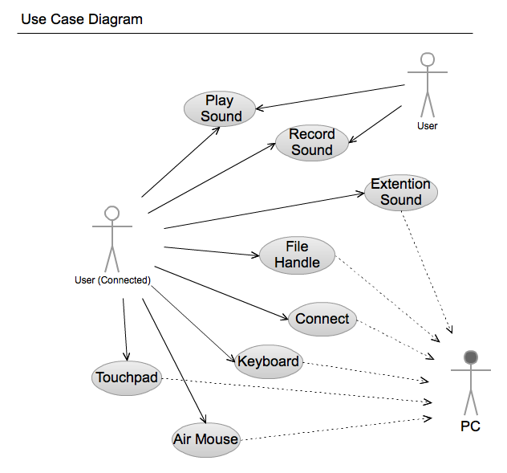

## 2.1 User requirements

- The system should provide users with connectivity features.  
- The system should be able to enter the required information to connect to user.

- The system should be telling wrong, if the user's connection information is wrong.  
- The system will be allowed use some features, even though system is not connected.  
- The system provides disconnect feature for the user.  
- The system provides the feature to store connected information.  
- The system provides the feature to record user's sound.  
 - The system should provide user's voice recording and allows user to enter information in the file.

- The system should allowstoringuser’s recorded sound.

- The system should allowmanaging files stored.

- The system provides the feature to transfer user’s voice to PC  
 - The system should be prevented delays when transfer sound.  
- The system provides user's mouse pointer control.  
- The system provides user's mouse click control.  
- The system provides user's motion mouse pointer control.  
- The system provides user's keyboard control.  
- The system provides the feature to save files.  
 - The system should show the details of the file.  
- The system provides the feature to transfer files.

- The system should show the list of stored files.

## 2.2 System requirements

- The system provides a connection between PC to device.

- The system might be able to input data needed by user in order to connect between PC to device

- When it failed to connect, a notice will be shown.

- User might be able to using system partially without connection.

- The system provides a result depends on connection.

- System provides the feature to connected user as follows.

- PC in the sound transmission.

- The system activate the feature to transmit a sound to PC

- Mouse control

- The system activate the feature to transmit a movement of mouse controlled by user to PC

- File transmission

- The system provides the feature to transmit user selected file to PC

- The system provides a function to do not connect user as follows.

- Recording

- The system saves a voice in the device.

- Showing file list

- The system providesthe feature to show a file in the device.

- The system provides the feature to user wanted connect to system as follows.

- Trying to connect to the system asks to enter the eigenvalues ​​of the PC.

- The user must enter the correct value that does not deviate from the type of eigenvalues at prompt.

- The system provides disconnect feature to the PC.

- The system provides that feature disconnection information to user that want to disconnect.

- The system provides feature to record sound..

- When user wants record the system provides enabled recording option feature to user.

- The system provides feature that transmit for user voice.

- When user want transmit the voice to PC the system provides feature after enabled option.

- The device must be requiring input the voice through the microphone.

- The system provides mouse control feature.

- The pointer that out of range should not move.

- It is prevented that multiple input pointing.

- The system activate feature to users who want to click.

-The mouse provides the ability to control points that user's movement.

- It should handle user's move within the area shall be controlled in system.

- The system provides keyboard control.

-The user should not require process that consistmultipleactions in time.

- The system provides file transmission.

- The system provides detail information of file for using to user.

- The user activate transfer files menu.

## 2.3 Domain requirements

- When the system error occurs, the system records error cause and the time information.  
- When system creates a voice file in system storage should not be exceeded more than create a file.  
- The system can handle only allows handling for the file type.  
- The system file processing and file processing is handled separately about other details.  
- The system is used Two-dimensional version of the labeling system (e.g. 1.0).

**3. Requirements Analysis**

## 3.1Structural Analysis

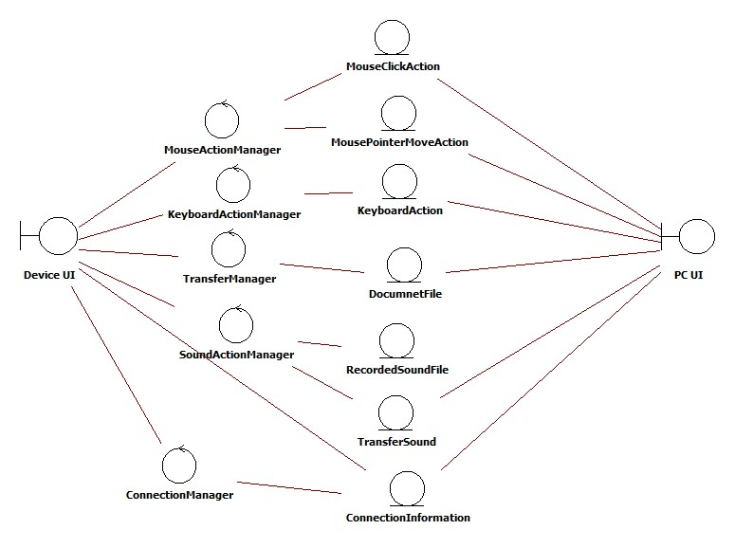

1. Boundary  
- Device UI provides the user interface, the main interaction between the user and the system. Used to initiate recording sounds, controlling mouse and keyboard actions, file transference to PC. Call the ConnectionManager to connect device and pc.  
- PC UI shows the ConnectionInformation that use when user wants to start system.  
  
2. Control  
- MouseActionManager is the controller that user can move mouse pointer of computer and do click action remotely.   
- KeyboardActionManager provides function that can use keyboard remotely.  
- SoundActionManager is the controller that records sound and plays recorded sound file.  
- ConnectionManager is the controller that used in the system-initiation step before another manamerstarts.  
- TrasferManager is the controller that sends document and sound files from device to pc.  
  
3. Entity  
- MousePointerMoveAction  
- MouseClickAction  
- KeyboardAction  
- DocumnetFile  
- RecordedSoundFile  
- ConnectionInformation  
- TransferSound

## 3.2. Behavioral Analysis

|  |  |  |  |  |
| --- | --- | --- | --- | --- |
| Use Case | Actor(s) | Entry Condition | Exit Condition | Extends/includes/inherits |
| Process Connecting | User | User want to that PC connected to Device for Presentation. | Device is connected to a PC. | Process Connecting |
| Move mouse using touchpad | User | PC’s mouse cursor position is moved in the user desired direction. | PC’s mouse cursor position is moved in the user desired direction. | Process Connecting |
| Click mouse using touchpad | User | User wants that mouse clickhappened on PC. | Click event will happen on PC that user wanted. | Process Connecting |
| Move mouse pointer using motion | User | Users want to move the PC’s mouse pointer by motion. | PC’s mouse cursor position is moved in the user desired direction, when user moves device. | Process Connecting |
| Control keyboard | User | User want to that keyboard event occurs on PC. | PC keyboard input occurs that is user-selected keyboard inputted of a Device. | Process Connecting |
| Process Record Sound | User | User wants to record user’s voice on Device. | User's voice is recorded on the Device. | Process Connecting |
| Process Play Sound | User | User wants to hear recorded contents. | Voice that is recorded in device is outputted through the speakers on the Device. | Process Connecting |
| Transfer voice to PC speaker | User | User wants its voice through the speakers on the PC is played in real time. | If User says, voice through the speakers on the PC is played in real time. | Process Connecting |
| Transfer voice to PC speaker | User | User wants to use files in the PC from the Device. | UC 1. Should be progressed. | Process Connecting |

|  |  |
| --- | --- |
| **Use Case 1 :** | Process Connecting |
| **Scope :** | Dynamic Presentation |
| **Level :** | user-goal |
| **Primary Actor:** | user |
| **Stakeholders and interests:** | User want to that PC connected to Device for Presentation. |
| **Preconditions:** | None. |
| **Success Guarantee :** | Device is connected to a PC. |
| **Main Success Scenario :** | 1. PC displays the information that can connect to PC.  2. Device makes user to input information that can connect to PC.  3. User enter the PC’s information to connect on Device  4. PC will compare to information with user’s input.  5. PC and Device notice the success connection. |
| **Extensions :** | 5a. If connection failed  1. Device notify to user that connection failed.  2. Device ask to user that user try to reconnection.  2.a If user want to try reconnection.  1. User enter the PC’s information to connect on Device.(Main #3.)  2.b If user want not to try reconnection.  1. System cancel the connecting action. |
| **Special Requirements:** | None. |
| **Frequency of Occurrence:** | Occurs only once at the initial operation. |
| **Open Issues:** | Before user enter the information directly, The system will show a list could be connected?  Is there any way other method of connection that proposed? |
|  | C:\Users\ajou\Desktop\Dropbox\Capston Project\종설 문서\Requirements Doc\Requirements Doc\AD_Connect.png |

|  |  |
| --- | --- |
| **Use Case 2 :** | Move mouse using touchpad |
| **Scope :** | Dynamic Presentation |
| **Level :** | user-goal |
| **Primary Actor:** | user |
| **Stakeholders and interests:** | Users want to move the PC’s mouse pointer. |
| **Preconditions:** | UC 1. Should be progressed. |
| **Success Guarantee :** | PC’s mouse cursor position is moved in the user desired direction. |
| **Main Success Scenario :** | 1. Device shows the User to move the mouse by touchpad.  2. User places its finger on Device’s screen, and then it moves in the desired direction.  3. PC shows the movement of the mouse pointer in user's desired direction. |
| **Extensions :** | \*a. If system failed.  1. If between PC and Device connection is lost.  1. Device found out that disconnected from PC.  2. Device attempts to reconnect based on information used in UC.1  2.a If external problem occurs that prevent connection.  1. System notifies the user for problem by Device.  2. If system terminated.  1. User restarts system for resolving problem. |
| **Special Requirements:** | User should be able to adjust mouse sensitivity.  Move the mouse pointer should be executed immediately |
| **Frequency of Occurrence:** | Frequently occurs. |
| **Open Issues:** | System as the difference between the sizes of the screen by any modifications needed?  How strong is user's sensitivity to feel comfortable? |
|  | C:\Users\ajou\Desktop\Dropbox\Capston Project\종설 문서\Requirements Doc\Requirements Doc\AD_Touchpad.png |

|  |  |
| --- | --- |
| **Use Case 3 :** | Click mouse using touchpad |
| **Scope :** | Dynamic Presentation |
| **Level :** | user-goal |
| **Primary Actor:** | user |
| **Stakeholders and interests:** | User wants that mouse clickhappened on PC. |
| **Preconditions:** | UC 1. Should be progressed. |
| **Success Guarantee :** | Click event will happen on PC that user wanted. |
| **Main Success Scenario :** | 1. Device shows the User to click the mouse.  2. User select mouse click on Device.  3. Device notifies that user’s action is normally processed. |
| **Extensions :** | \*a. If system failed.  1. If between PC and Device connection is lost.  1. Device found out that disconnected from PC.  2. Device attempts to reconnect based on information used in UC.1  2.a If external problem occurs that prevent connection.  1. System notifies the user for problem by Device.  2. If system terminated.  1. User restarts system for resolving problem.  2.a If user select mouse left click.  1. PC generates mouse left click event.  2.b If user select mouse right click.  1. PC generates mouse right click event. |
| **Special Requirements:** | Click the mouse on PC should be executed immediately.  Device uses sound and vibration for notify that user’s action is normally processed. |
| **Frequency of Occurrence:** | Frequently occurs. |
| **Open Issues:** | None. |
|  | C:\Users\ajou\Desktop\Dropbox\Capston Project\종설 문서\Requirements Doc\Requirements Doc\AD_MouseClick.png |

|  |  |
| --- | --- |
| **Use Case 4 :** | Move mouse pointer using motion |
| **Scope :** | Dynamic Presentation |
| **Level :** | user-goal |
| **Primary Actor:** | User |
| **Stakeholders and interests:** | Users want to move the PC’s mouse pointer by motion. |
| **Preconditions:** | 1. UC 1. Should be progressed.  2. Device must operate acceleration sensor. |
| **Success Guarantee :** | PC’s mouse cursor position is moved in the user desired direction, when user moves device. |
| **Main Success Scenario :** | 1. Device shows the user to move the mouse by motion.  2. User moves Device in the direction.  3. PC shows the movement of the mouse pointer in user's desired direction. |
| **Extensions :** | \*a. If system failed.  1. If between PC and Device connection is lost.  1. Device found out that disconnected from PC.  2. Device attempts to reconnect based on information used in UC.1  2.a If external problem occurs that prevent connection.  1. System notifies the user for problem by Device.  2. If system terminated.  1. User restarts system for resolving problem. |
| **Special Requirements:** | The mouse pointer moves by the motion must be executed immediately. |
| **Frequency of Occurrence:** | Frequently occurs. |
| **Open Issues:** | How strong is user's sensitivity to feel comfortable? |
|  | C:\Users\ajou\Desktop\Dropbox\Capston Project\종설 문서\Requirements Doc\Requirements Doc\AD_MotionMouse.png |

|  |  |
| --- | --- |
| **Use Case 5 :** | Control keyboard |
| **Scope :** | Dynamic Presentation |
| **Level :** | user-goal |
| **Primary Actor:** | User |
| **Stakeholders and interests:** | User want to that keyboard event occurs on PC. |
| **Preconditions:** | UC 1. Should be progressed. |
| **Success Guarantee :** | PC keyboard input occurs that is user-selected keyboard inputted of a Device. |
| **Main Success Scenario :** | 1. Device shows the user a choice of possible keyboard actions.  2. User selects keyboard action on the Device.  3. Device notifies that user’s action is normally processed.  4. PC executes user-selected keyboard action. |
| **Extensions :** | \*a. If system failed.  1. If between PC and Device connection is lost.  1. Device found out that disconnected from PC.  2. Device attempts to reconnect based on information used in UC.1  2.a If external problem occurs that prevent connection.  1. System notifies the user for problem by Device.  2. If system terminated.  1. User restarts system for resolving problem. |
| **Special Requirements:** | Device uses sound and vibration for notify that user’s action is normally processed.  Keyboard operation must be executed immediately |
| **Frequency of Occurrence:** | Frequently occurs. |
| **Open Issues:** | None. |
|  | C:\Users\ajou\Desktop\Dropbox\Capston Project\종설 문서\Requirements Doc\Requirements Doc\AD_Keyboard.png |

|  |  |
| --- | --- |
| **Use Case 6 :** | Process Record Sound |
| **Scope :** | Dynamic Presentation |
| **Level :** | user-goal |
| **Primary Actor:** | User |
| **Stakeholders and interests:** | User wants to record user’s voice on Device. |
| **Preconditions:** | Device has an audio input device. |
| **Success Guarantee :** | User's voice is recorded on the Device. |
| **Main Success Scenario :** | 1. Device makes user to choose recording voice.  2. User should select the voice recording.  3. Device notifies to recording starts.  4. User should enter the voice on the Device.  5. User stop the speaking. |
| **Extensions :** | \*a. If system failed.  1. If between PC and Device connection is lost.  1. Device found out that disconnected from PC.  2. Device attempts to reconnect based on information used in UC.1  2.a If external problem occurs that prevent connection.  1. System notifies the user for problem by Device.  2. If system terminated.  1. User restarts system for resolving problem.  5.a If user want to save recording voice.  1. User unselect recording voice.  2. User saves the recorded voice.  5.b If user want to continue recording voice.  1. User re-select voice recording. |
| **Special Requirements:** | Device must have space to store the voice in.  User-recorded voice of the original speech and should not be a big difference.  User should be able to control the volume that sound stored in device. |
| **Frequency of Occurrence:** | Sometimes. |
| **Open Issues:** | None. |
|  | C:\Users\ajou\Desktop\Dropbox\Capston Project\종설 문서\Requirements Doc\Requirements Doc\AD_RecordSound.png |

|  |  |
| --- | --- |
| **Use Case 7 :** | Process Play Sound |
| **Scope :** | Dynamic Presentation |
| **Level :** | user-goal |
| **Primary Actor:** | User |
| **Stakeholders and interests:** | User wants to hear recorded contents. |
| **Preconditions:** | None. |
| **Success Guarantee :** | Voice that is recorded in device is outputted through the speakers on the Device. |
| **Main Success Scenario :** | 1. Device makes user to choose play recorded contents.  2. User chooses to play the recorded voice.  3. Device shows a list of the recorded voice to the user.  4. User selects recording the voice in list.  5. System makes the user to listen the selected voice. |
| **Extensions :** | \*a. If system failed.  1. If between PC and Device connection is lost.  1. Device found out that disconnected from PC.  2. Device attempts to reconnect based on information used in UC.1  2.a If external problem occurs that prevent connection.  1. System notifies the user for problem by Device.  2. If system terminated.  1. User restarts system for resolving problem.  3.a If device not have a recorded voice.  1. Device notifies that there is a recorded voice.  5.a If system fails play the recorded voice.  1. Device notifies to user of problem. |
| **Special Requirements:** | User shall be able to adjust the volume. |
| **Frequency of Occurrence:** | None. |
| **Open Issues:** | Only playback of recorded voice will provide on Device?  The concept of sharing will need to be added? |
|  | C:\Users\ajou\Desktop\Dropbox\Capston Project\종설 문서\Requirements Doc\Requirements Doc\AD_PlaySound.png |

|  |  |
| --- | --- |
| **Use Case 8 :** | Transfer voice to PC speaker |
| **Scope :** | Dynamic Presentation |
| **Level :** | user-goal |
| **Primary Actor:** | User |
| **Stakeholders and interests:** | User wants its voice through the speakers on the PC is played in real time. |
| **Preconditions:** | UC 1. Should be progressed. |
| **Success Guarantee :** | If User says, voice through the speakers on the PC is played in real time. |
| **Main Success Scenario :** | 1. Device makes user to choose transfer voice to PC speaker.  2. User chooses to transfer voice to PC speaker.  3. User should enter the voice on the Device.  4. PC output the voice that entered by the user.  5. User terminates voice transfer. |
| **Extensions :** | \*a. If system failed.  1. If between PC and Device connection is lost.  1. Device found out that disconnected from PC.  2. Device attempts to reconnect based on information used in UC.1  2.a If external problem occurs that prevent connection.  1. System notifies the user for problem by Device.  2. If system terminated.  1. User restarts system for resolving problem.  5.a If user wants to continue transfer voice.  1. User should enter the voice on the Device.(Main Scenario #3.)  5.b If user wants not to continue transfer voice.  1. User deselects voice transfer. |
| **Special Requirements:** | User's real-time voice transmission should be executed immediately.  User's voice input of the time and output to the PC's speakers of the time difference should be enough not to inconvenience.  Device and the PC support that user should be able to adjust the volume. |
| **Frequency of Occurrence:** | Frequently occurs. |
| **Open Issues:** | How could reduce voice transmission time? |
|  | C:\Users\ajou\Desktop\Dropbox\Capston Project\종설 문서\Requirements Doc\Requirements Doc\AD_ExtentionSound.png |

|  |  |
| --- | --- |
| **Use Case 9 :** | Transfer document |
| **Scope :** | Dynamic Presentation |
| **Level :** | user-goal |
| **Primary Actor:** | User |
| **Stakeholders and interests:** | User wants to use files in the PC from the Device. |
| **Preconditions:** |  |
| **Success Guarantee :** | UC 1. Should be progressed. |
| **Main Success Scenario :** | 1. Device makes User to choose file transmission.  2. User select file transmission.  3. Device shows the complete list of available files to send.  4. User selects the file.  5. Device shows the file selected by the user.  6. Users should check the correct of the selected file.  7. Device shows the file transfer process.  8. System will execute the file selected by the user. |
| **Extensions :** | \*a. If system failed.  1. If between PC and Device connection is lost.  1. Device found out that disconnected from PC.  2. Device attempts to reconnect based on information used in UC.1  2.a If external problem occurs that prevent connection.  1. System notifies the user for problem by Device.  2. If system terminated.  1. User restarts system for resolving problem.  3a. If file list is empty.  1. System notifies to the user that file list is empty.  6a. If user wants to transfer other files.  1. User cancels the file transfer.  2. Goto Main Scenario #1. |
| **Special Requirements:** | Transfer files with other UC should be operated. |
| **Frequency of Occurrence:** | Sometimes. |
| **Open Issues:** | None. |
|  | C:\Users\ajou\Desktop\Dropbox\Capston Project\종설 문서\Requirements Doc\Requirements Doc\AD_FileHandling.png |

**3.3Analysis Packages**

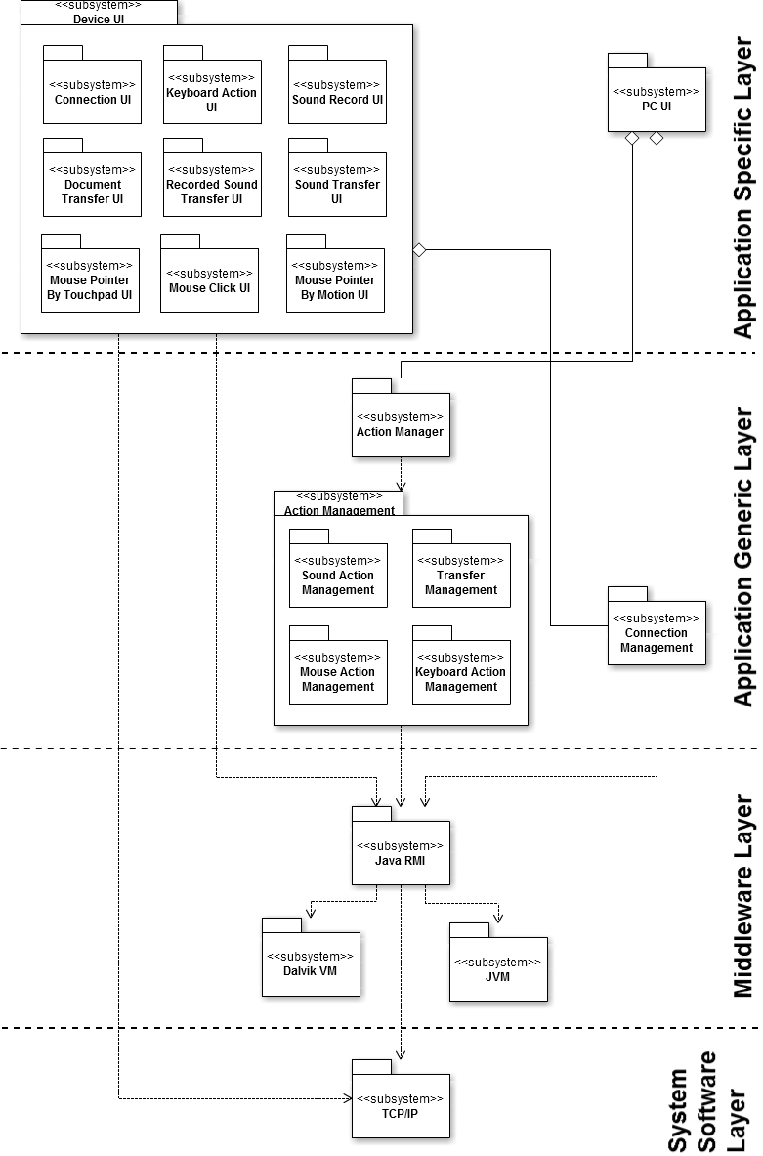

3.1.1 Application Specific Layer

This layer consists of the Device UI subsystem and PC UI subsystem. The Device UI further consists of the ConnectionUI, KeyboardActionUI, SoundRecordUI, DocumnetTransferUI, RecordedSoundTransferUI, SoundTransferUI, MousePointerByTouchpadUI, MouseClickUI and MousePointerByMotionUI. The role of this subsystem is to create and manage the user interfaces and screens.

3.1.2. Application Generic Layer

This layer consists of the various sub-systems which are independent of the system and it consists of subsystem like Action Manager Facade, Sound Action Management, Transfer Management, Mouse Action Management, Keyboard Action Management and Connection Management. The Action Manager Facade handles request sent from Device UI and invokes the appropriate subsystem on the PC UI. The Connection Management interacts with Device UI and PC UI to initiate system.

3.1.3. Middleware Layer

This layer consists of the system specific subsystems like Java RMI, Dalvik VM and JVM. This layer provides the medium by which system can be developed in the manner desired. The upper layers realize this subsystem to communicate with other subsystems to perform appropriate functions. Since the middleware layer supports Java platform or Android platform, all this subsystem directly depends upon the JVM subsystem and Dalvik subsystem.

3.1.4. Application System Software Layer

This layer consists of TCP/IP subsystem. This layer provides the functionality to other subsystem to communicate over the network.

**4. Validation Criteria (metrics & measures)**

The following items are validation method for the use cases.  
In addition, when a use case validation, strategy should be used is described.  
  
- Connecting use case (UC 1: Process Connecting)  
This use case will be tested by direct experiment.  
This use case is a prerequisite for the other use cases. Therefore, the accuracy and reliability is a key measurement target.  
  
- Control related use case (UC 2: Move mouse using touchpad, UC 3: Click mouse using touchpad, UC 4: Move mouse pointer using motion, UC 5 : Control keyboard)  
These use cases for each feature will be tested by direct experiment.The most important measure by the user whether or not the desired behavior is exactly reproducible.  
User does not feel at the time the works will be measured.  
In addition, each use case that progressed normally, user able to is make sure that.  
  
- Voice related use case (UC 6: Record voice, UC 7: Play recorded voice, UC 8: Transfer voice to PC speaker)  
These use cases for each feature will be tested by direct experiment.  
In addition, the user's voice and the voice is processed by the system's time difference is being measured is important.  
It will be measured that the difference between user’s original voice and the voice that processed by the system.

- Cloud service use case (UC 9: Transfer document)  
These use cases for each feature will be tested by direct experiment.  
Because there should be no errors will measure the integrity.

**5. Appendices**

Applying UML And Patterns, 3rdEd.  
Google Docs –Real Time Document **Collaboration**  
Gliffy–diagramming tools  
TeamViewer– Remote Controll Collaboration  
[www.cacoo.com](http://www.cacoo.com)- diagramming tools